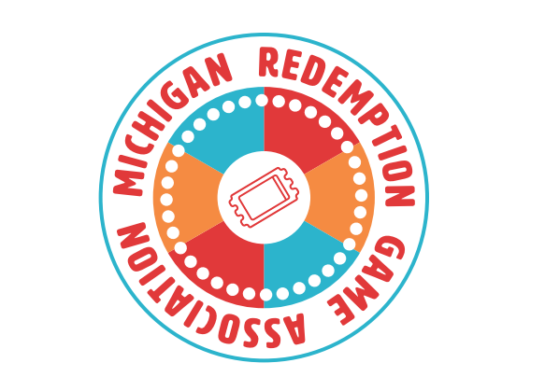

[DATE]
Dear [LAWMAKER]
As you know, neighborhood taverns, mom-and-pop restaurants and local social halls in our communities have been devastated by the pandemic over the past two years.
These businesses and venues are the fabric of communities across Michigan, providing people a place to gather and connect. They also power our local economies, creating jobs, investment and opportunities.
At a time when these small businesses need our help now more than ever, a key part of their revenue stream is under threat. State agencies are aggressively and wrongly targeting businesses that offer redemption games for play. These games, which can be found at restaurants, bars and clubs across Michigan, include crane games, pusher bar games, and electronic games of skill that allow a player to win prizes ranging from stuffed animals to gift cards. They’re fun and harmless, and they provide much needed revenue to restaurants, bars and clubs throughout the state.
In these challenging times, the Michigan Legislature should do everything in its power to help small businesses survive and thrive, including recognizing the important role redemption games play in attracting customers, driving foot traffic and generating revenues.
That’s why I support this important piece of legislation. It would provide certainty to this industry that has existed for decades and would clarify the regulatory system for redemption games, which have been around since 1997. It lays out a clear definition of this industry and provide protection for small businesses that will help them succeed.
I urge you to support Senate Bill XXX because it will help bars, restaurants and social venues across Michigan stay on their feet now and into the future.

Thank you,
[NAME]

